**Faculty of Computing**

**Year 2 Semester 1 (2025)**

IT2120 - Probability and Statistics Lab Sheet 05

IT24100400 – Sandeepa M S

**Exercise**

1. 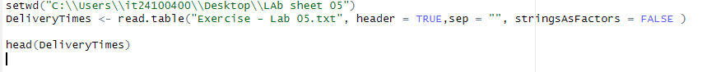A computer screen with text

   Description automatically generatedImport the dataset (’Exercise – Lab 05.txt’) into R and store it in a data frame called” Delivery Times”.
2. A computer code with text

   Description automatically generated with medium confidenceDraw a histogram for deliver times using nine class intervals where the lower limit is 20 and upper limit is 70. Use right open intervals.

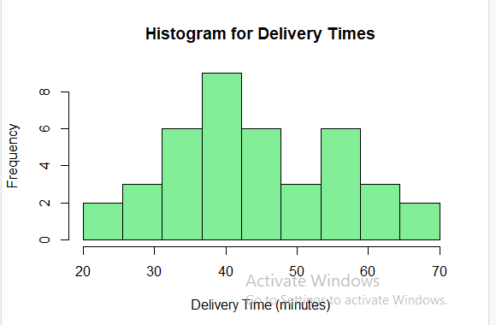

1. . Comment on the shape of the distribution

This distribution is approximately symmetric: because left and ride sides centers are balanced. Like normal distribution and not extreme outliers or long tails and its perfectly smooth because of the small sample.

4. Draw a cumulative frequency polygon (ogive) for the data in a separate plot.



